**Fur-ever Purr-fect Cat**

**Fur-ever Purr-fect Cat is** an Android application that unify cat lovers all over the world. This app use API provided by [**TheCatAPI**](https://thecatapi.com/). For further complete **documentation** please access the web yourself. Below is the wireframe for **Fur-ever Purr-fect Cat**. For **user** **authentication**, you can use this key: **a300b58e-b39c-4859-8548-683f03ac28cc**. There are **three** **main** **menus** in this application, they are:

1. **Home**

* A **random** **image** will be shown each time the application is **opened**
* There are three buttons for navigation to other **three** **menus**

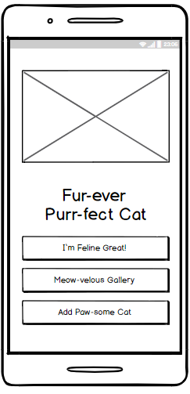

1. **I’m Feline Great!**

* User can view **random** **images** from database in **set of 9 images**. The images will be displayed with below pattern:

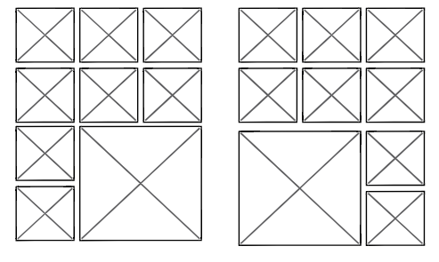

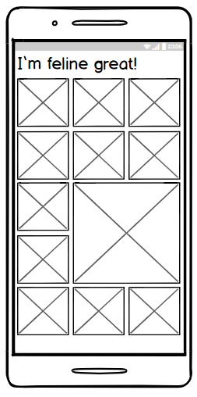

* User can **scroll** **down** the images infinitely **(infinite scrolling)**.
* User can click one image to display the image detail.
* There is a **toggle** **button** to **add the image into favorites** list **or** **remove** **it**.

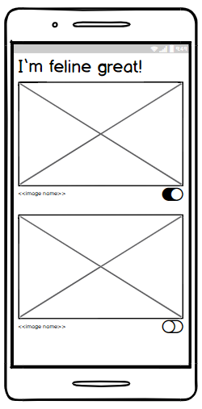

1. **Meowvelous Gallery**

* User can **view** their **favorite** **images** via this menu.
* There is a **toggle** **button** to **remove** **the** **images** **from** **the** **favorite** **list**.

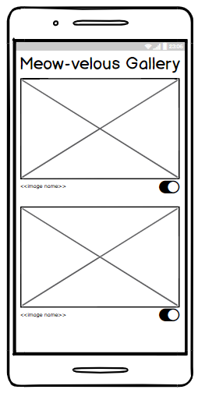

1. **Add Paw-some Cat**

* User can use this menu to **upload** **new** **images**
* Images uploaded this way will **automatically** **set** **as** **favorite** **image**.

